# Chapter 4 – Implementation

## 4.1 Introduction

Implementation is the process of converting the design of a system to the real system with the help of high level programming language coding. This phase helps to code the system which is designed on the design phase. It is the 3rd phase of the “Software Development Life Cycle”.

## 4.2 Programming Language

For this project, I have chosen HTML (Hypertext Markup Language) which can be used for developing the layout design and CSS (Cascading Style Sheet) for the proper manage of the HTML design on layout. And PHP (PHP: Hypertext Preprocessor) with OOP (Object Oriented Programming) for the backend process of the system like store, retrieve, update, delete data from the database.

## 4.3 Tools Used

The tools I have chosen for this phase are:

* **Operating system:** Windows 10.
* **Code Editor:** Sublime Text 3.
* **Browser:** Chrome
* **Database server:** MySQL
* **Server:** XAMPP

## 4.4 Coding Screenshot

Home Page:

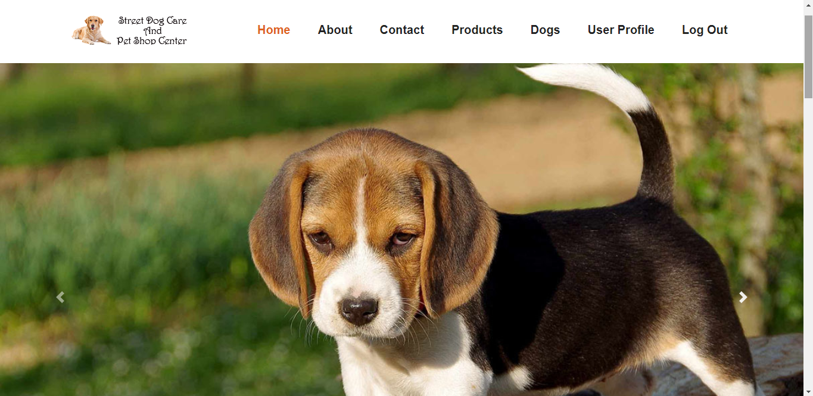

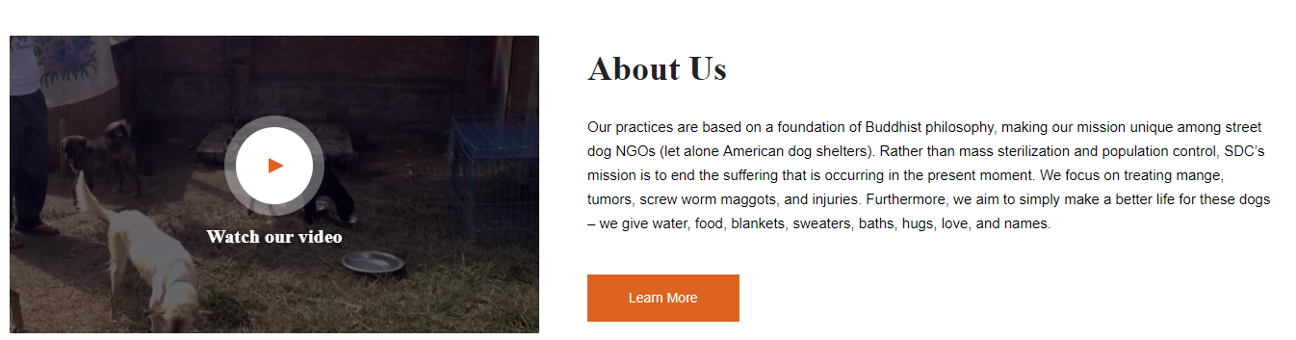

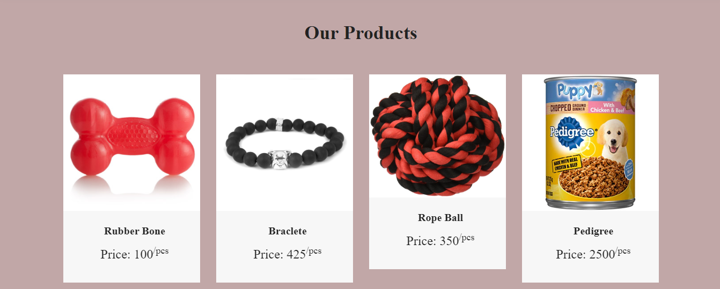

Home Page Code:

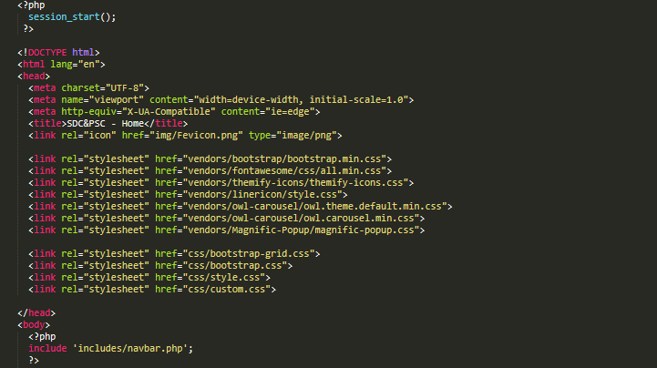

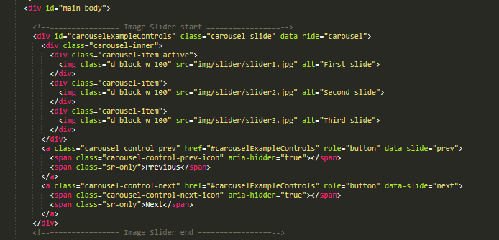

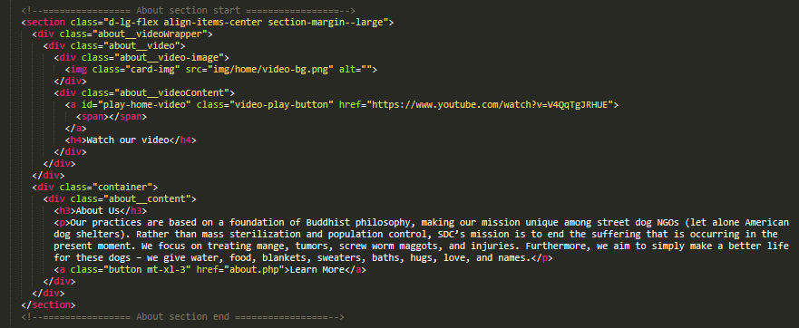

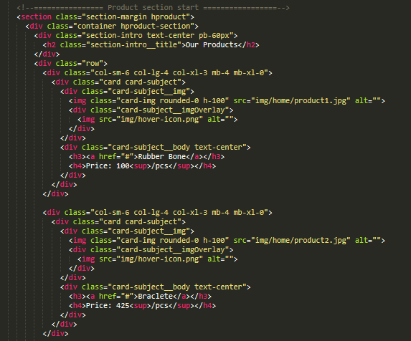

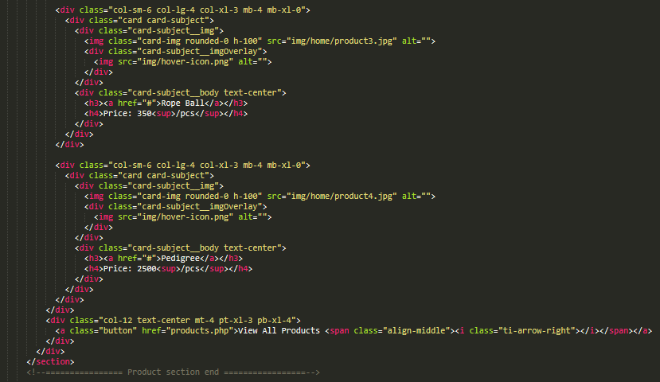

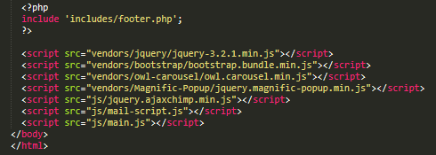

Admin Login Form:

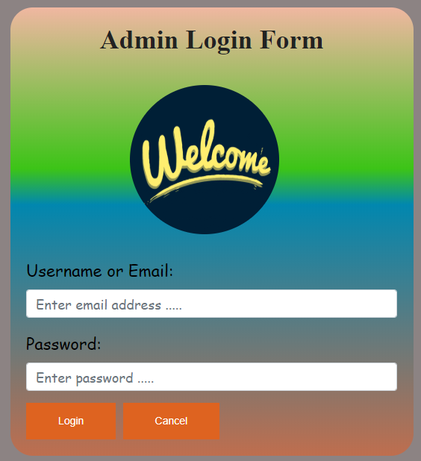

Admin Login Form Code:

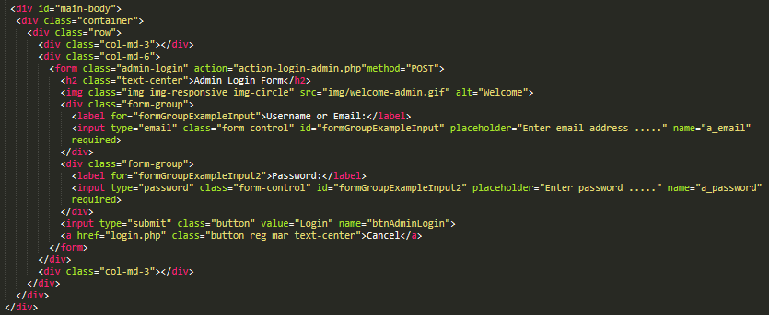

Admin Login Action Code:

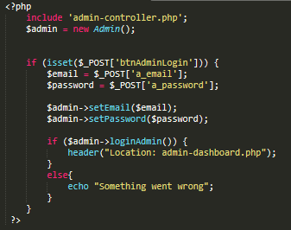

Admin Login Form Controller:

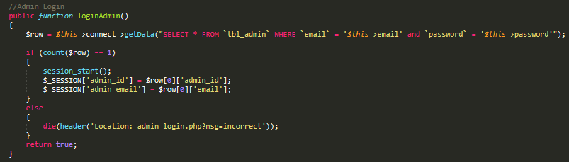

Admin Dashboard:

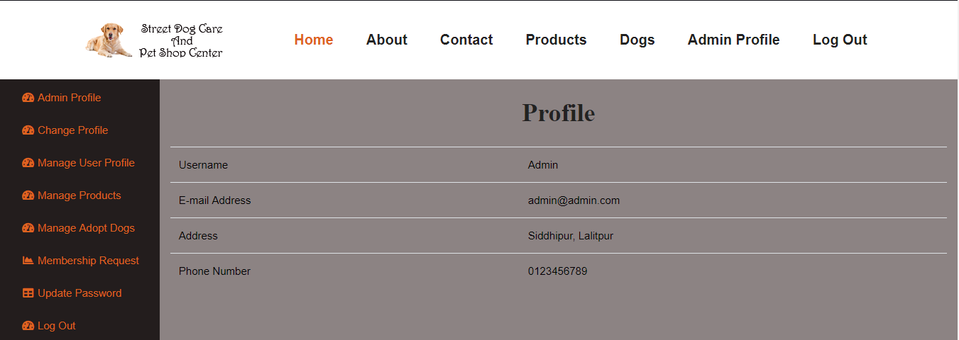

Admin Dashboard Code with logged in user profile:

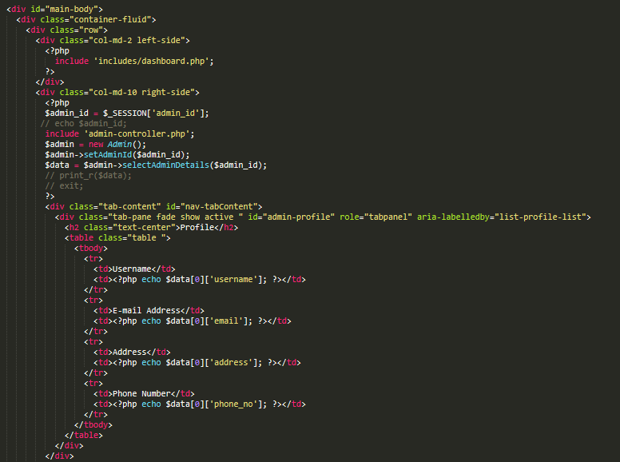

Fetch Date of Admin with their ID and without ID:

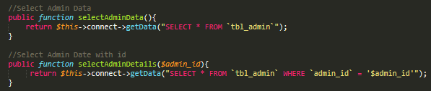

Admin Update Profile

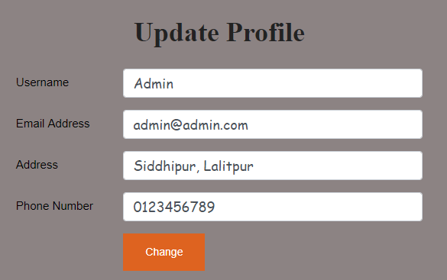

Fetch data according to the admin logged in:

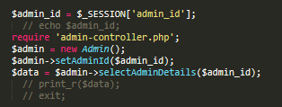

Admin Update Profile Form Code:

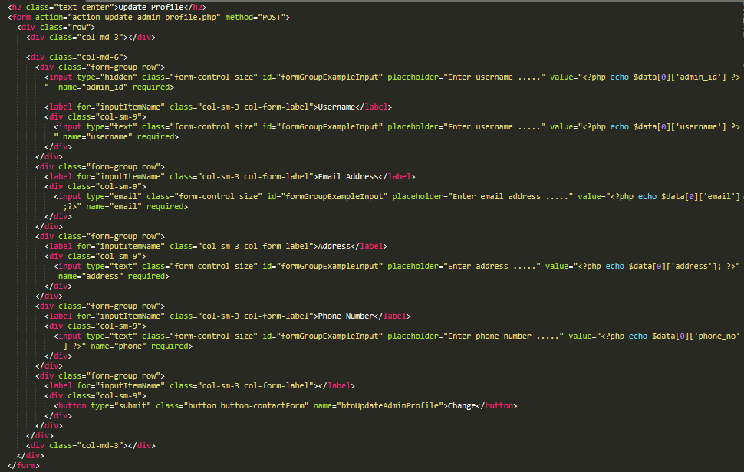

Update Admin Profile Action Code:

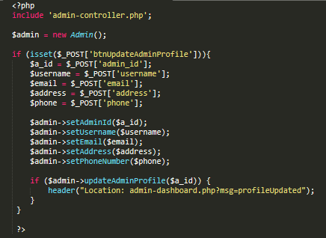

Update Admin Profile Controller Code:



Admin Manage User Profile:

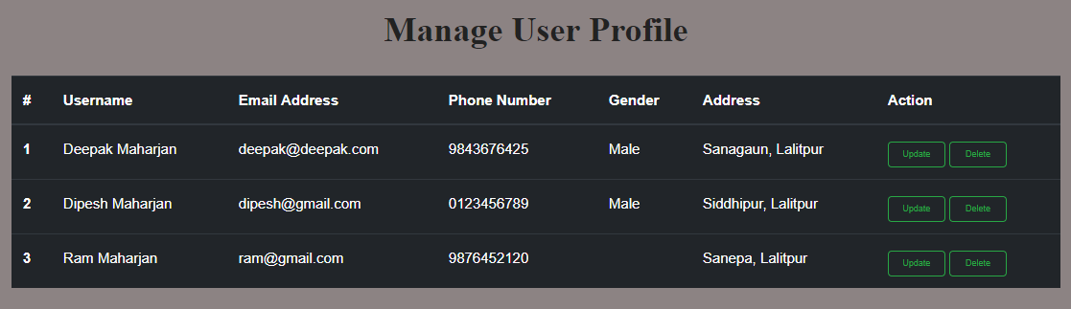

Manage User Profile Code:

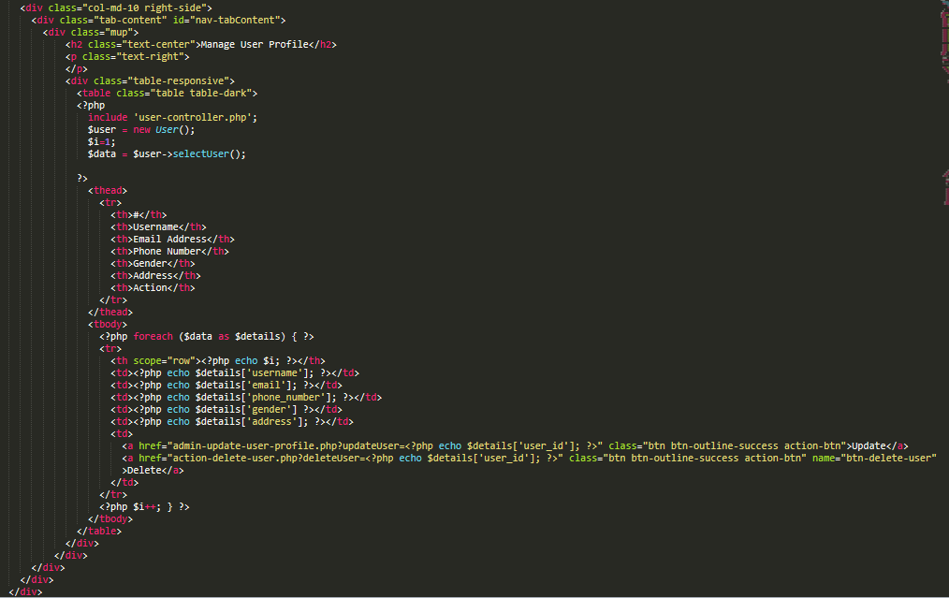

Update User Profile by Admin:

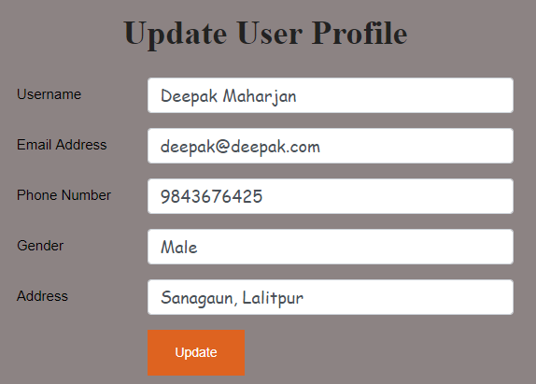

Admin Update User Profile Code:

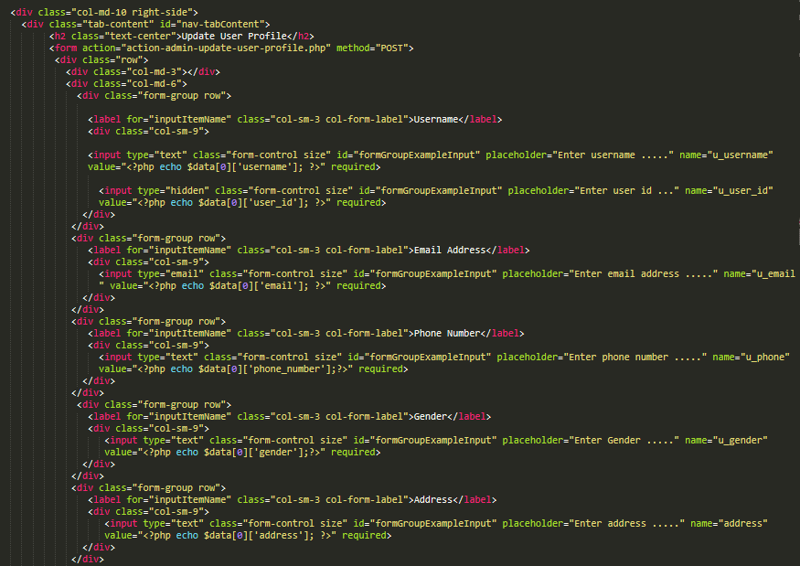

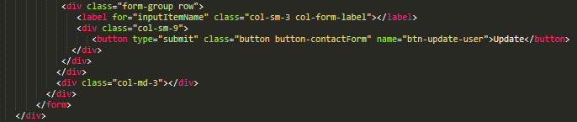

Action User Profile Update:

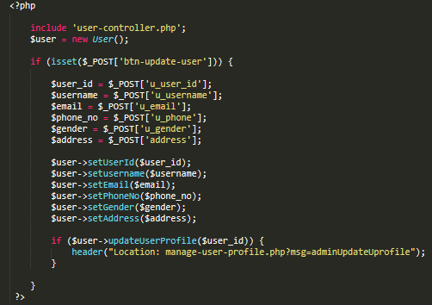

User Profile Update Controller:

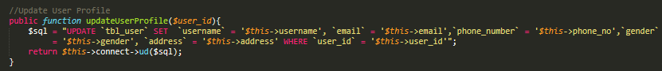

Delete User Action:

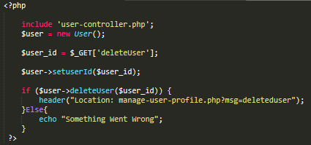

Delete User Controller:

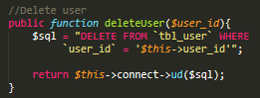

Manage Product:

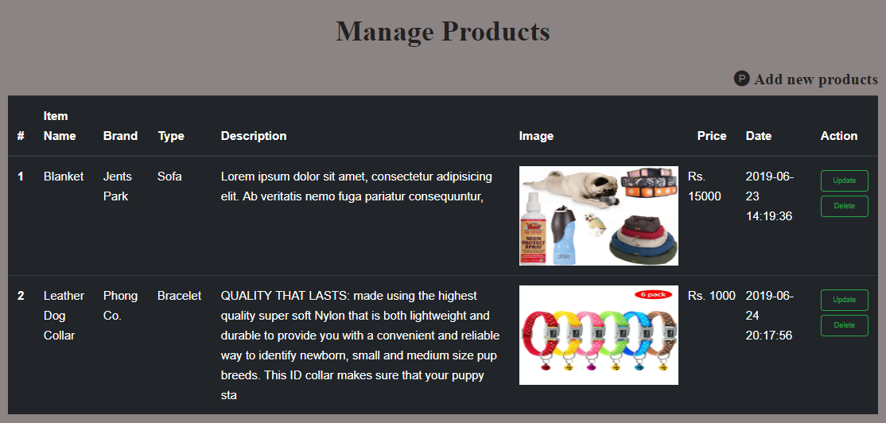

Manage Product Code:

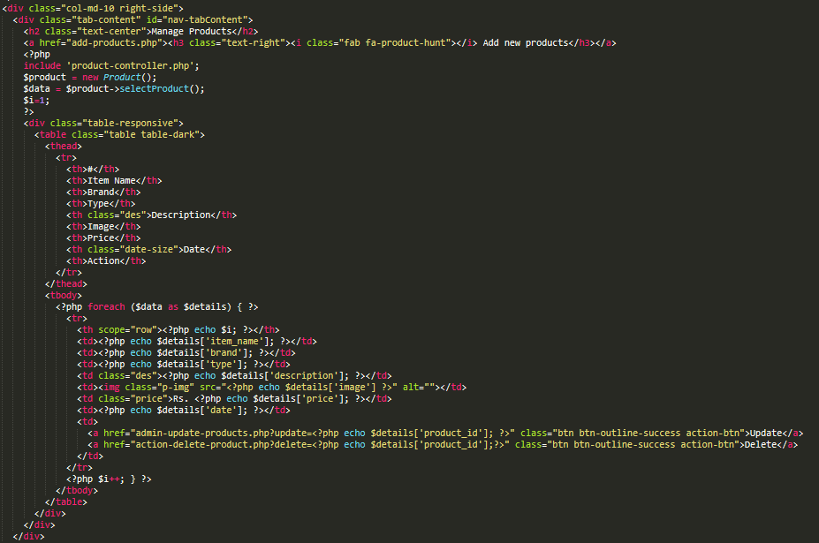

Add Product:

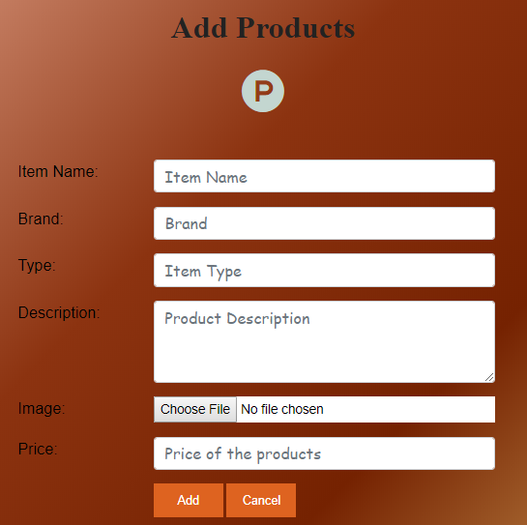

Add Product Form Code:

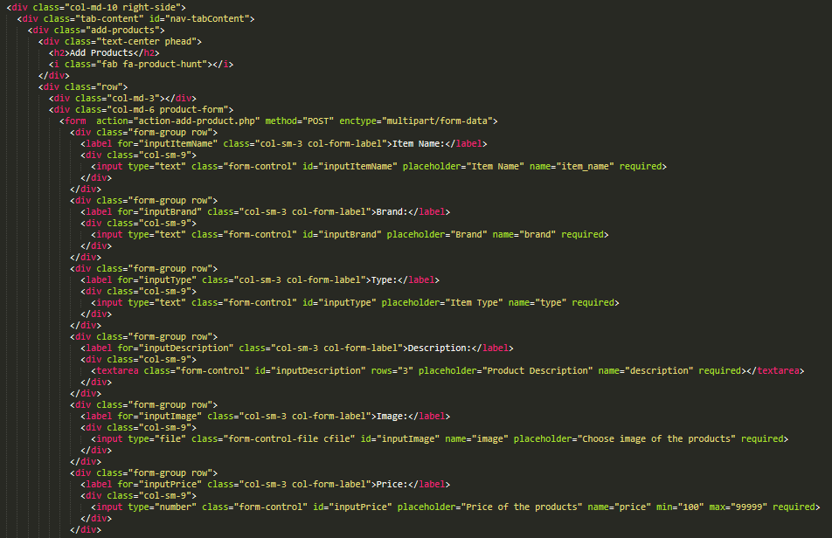

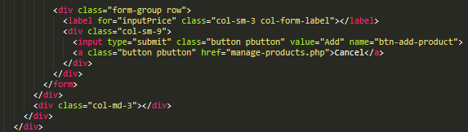

Add Product Action Code:

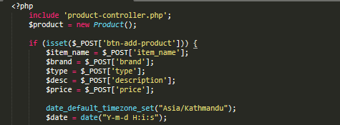

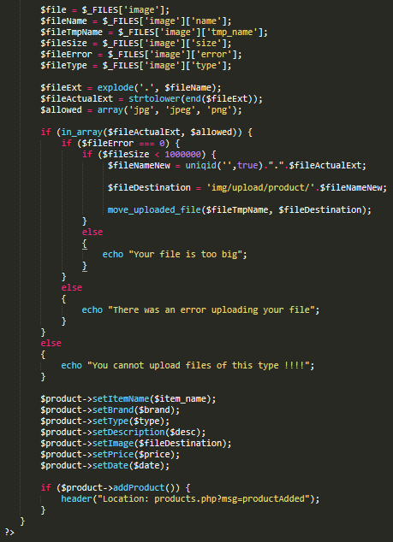

Add Product Controller:

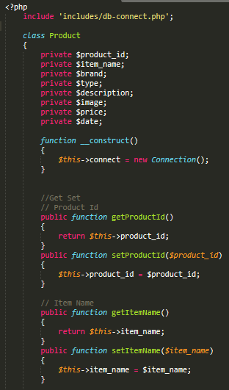

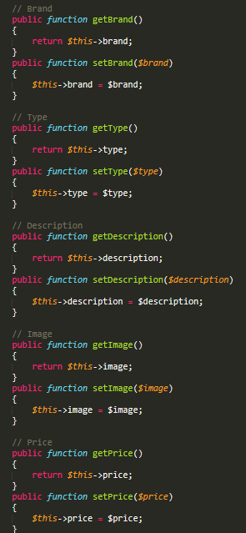

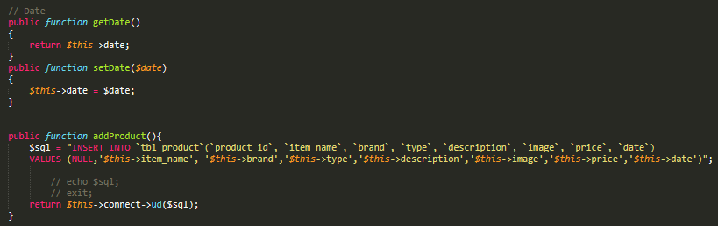

Update Product Form:

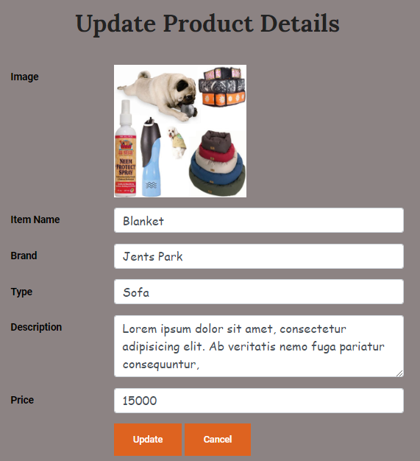

Update Product Details Form Code:

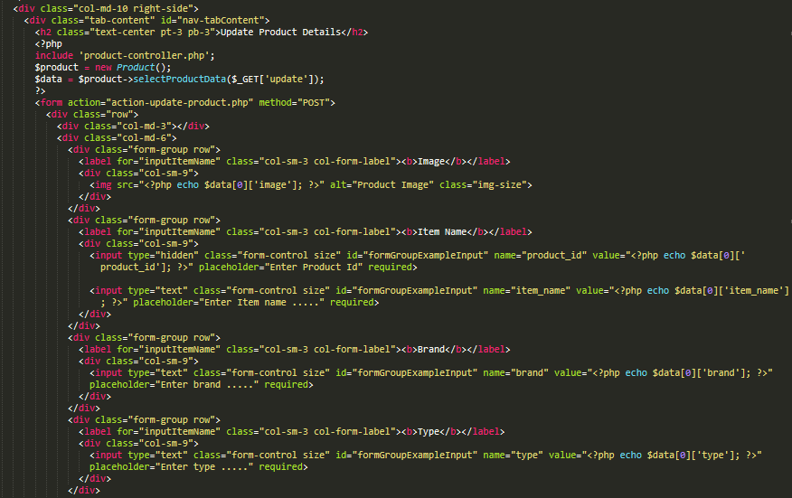

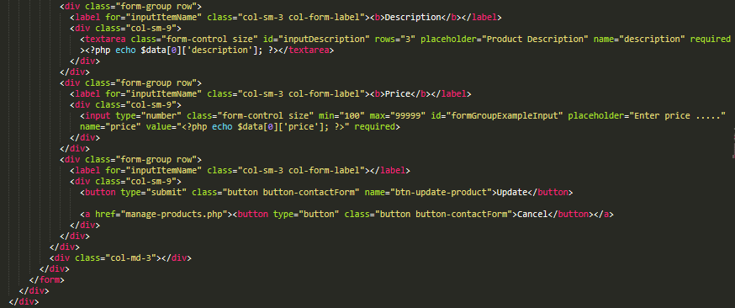

Update Product Details Action Code:

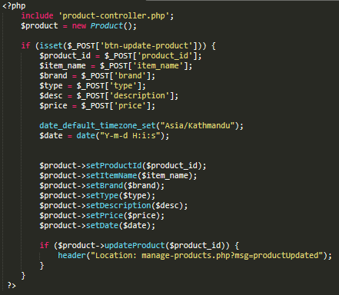

Update Product Controller (Select product details and update):

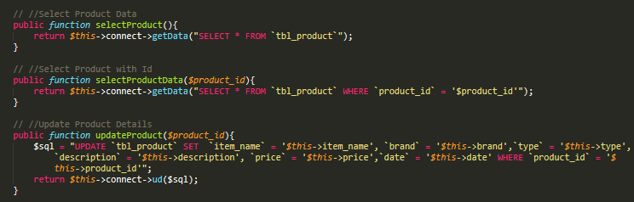

Delete product action code:

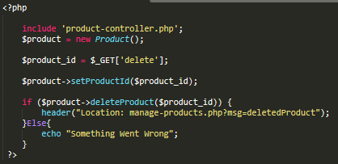

Delete product controller code:

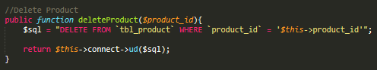

Manage Adopt Dogs:

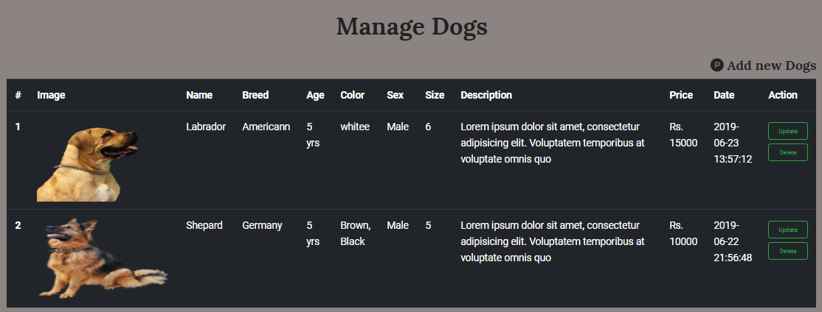

Add Dog Form:

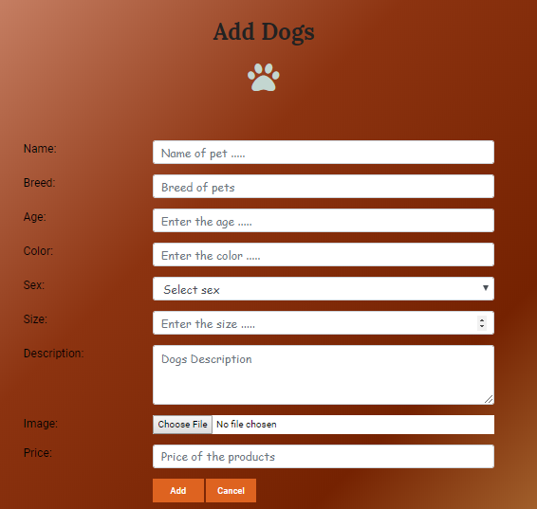

Action Add Dog:

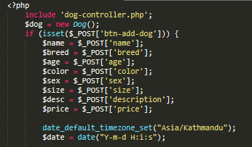

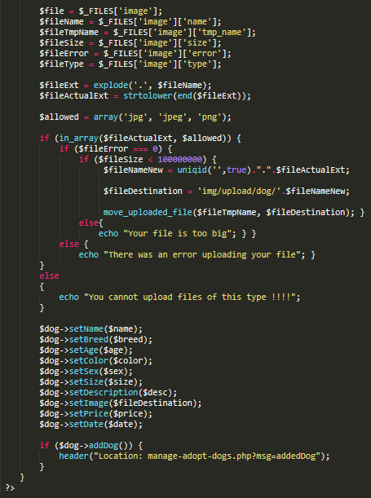

Add Dog Controller:

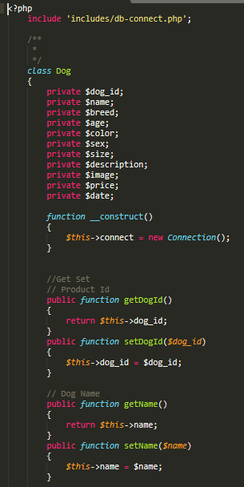

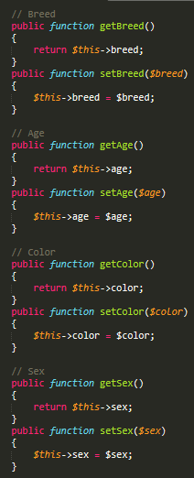

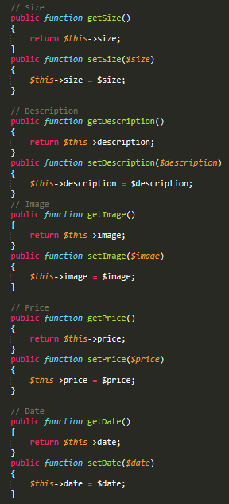

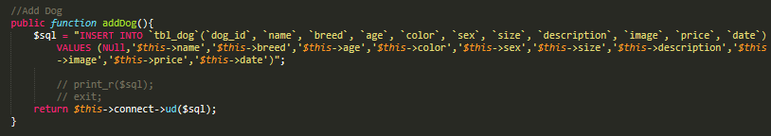

Update Dog:

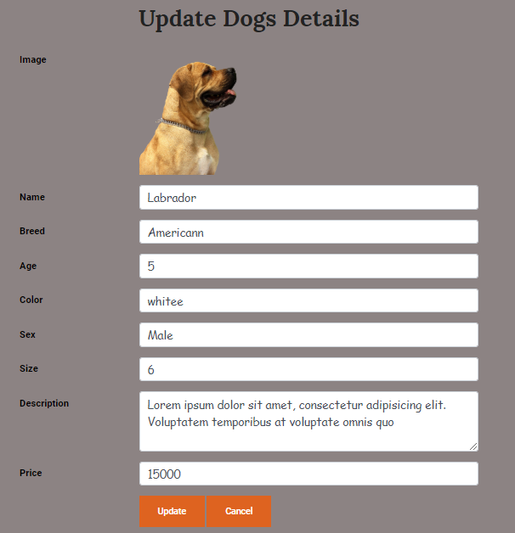

Update Dog Form Code:

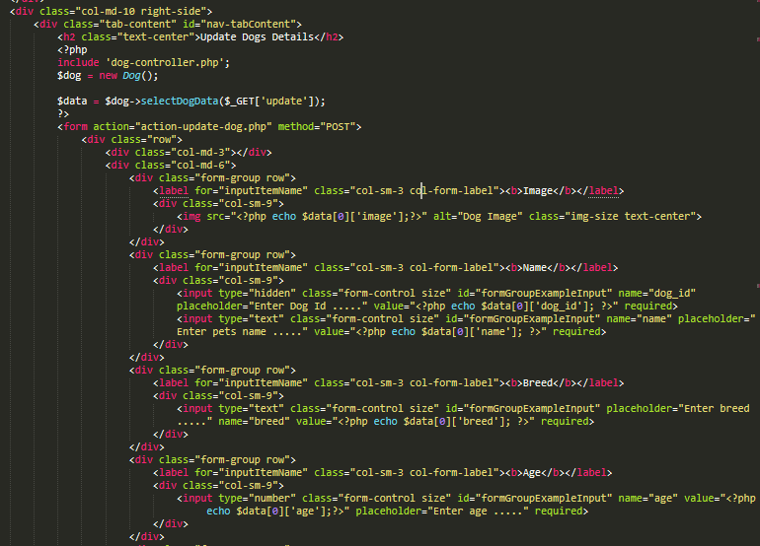

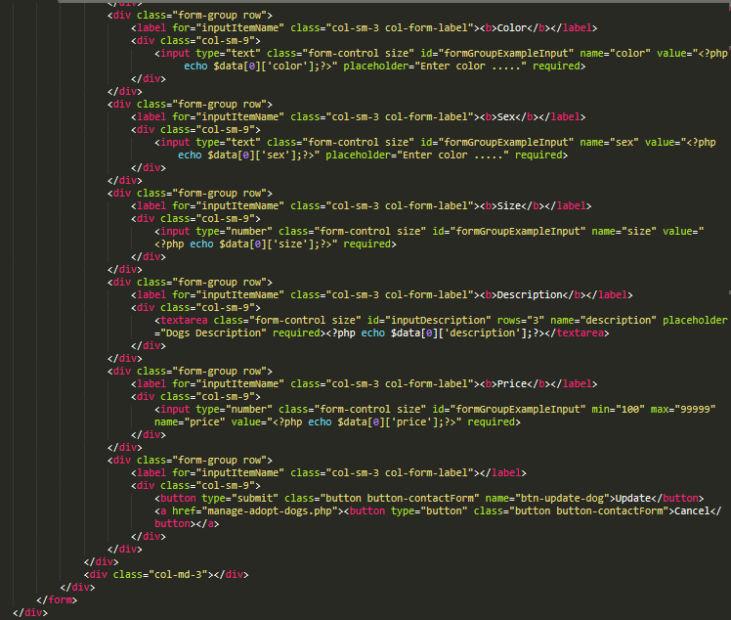

Update dog details action code:

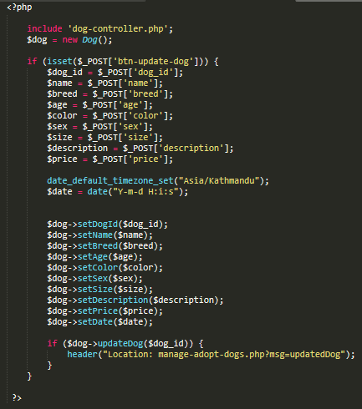

Select the dog and update their detail controller code:

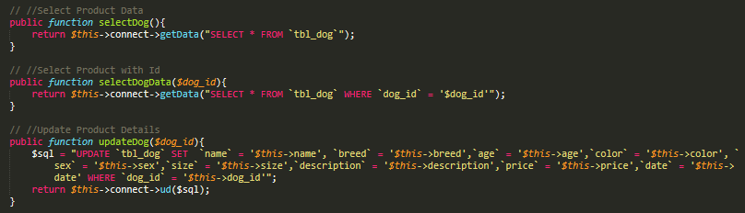

Delete Dog Action Code:

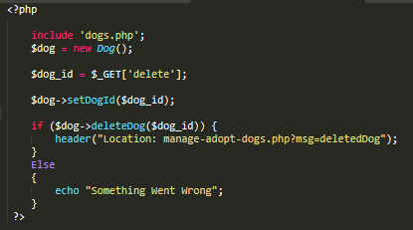

Delete Dog Controller Code:

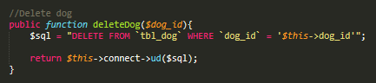

User sends request for a membership:

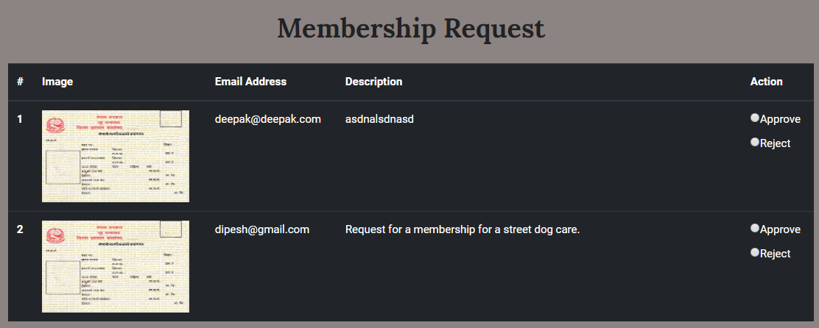

Membership request show details code:

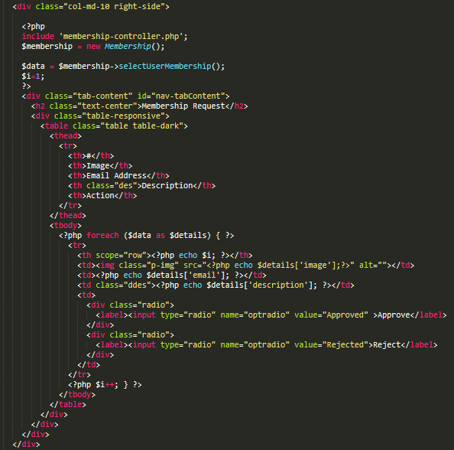

Fetch membership request:

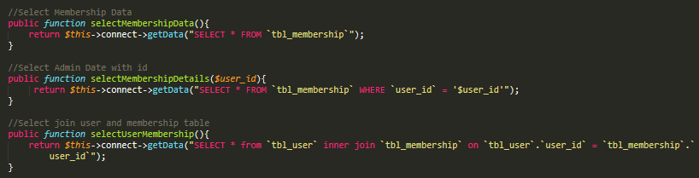

Update Admin Password:

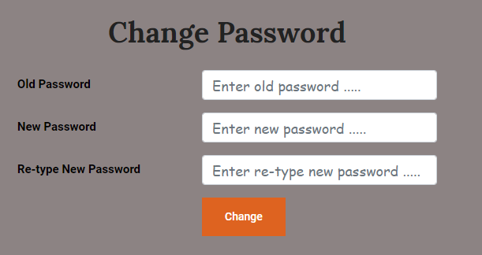

Admin change password form code:

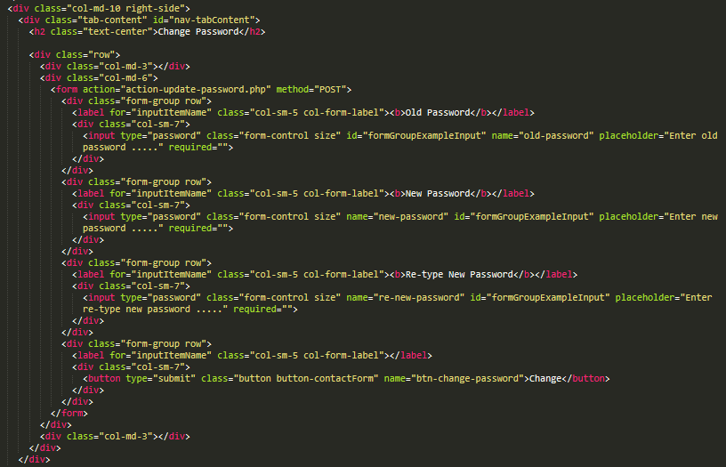

Admin change password action code:

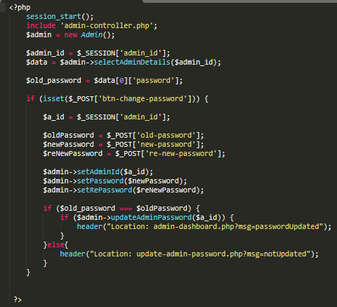

Admin change password controller code:

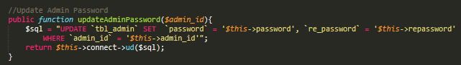

User Registration Form

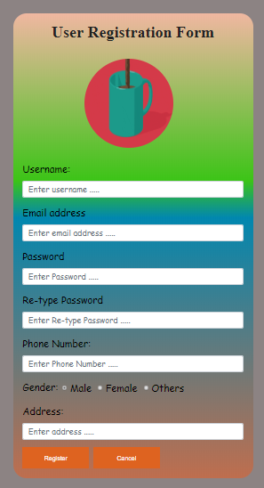

User Registration Form Code

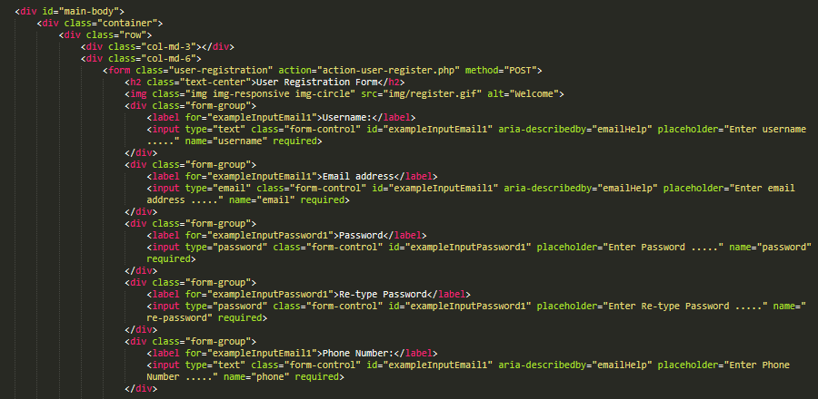

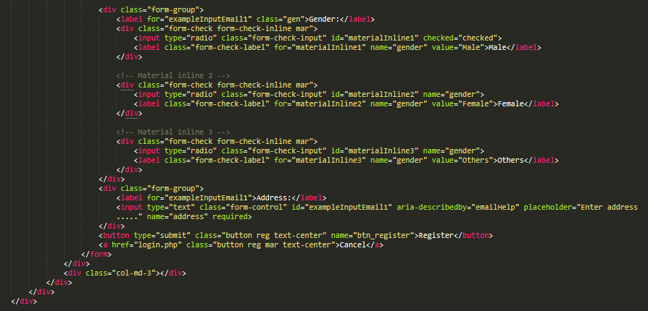

User Registration Action Code:

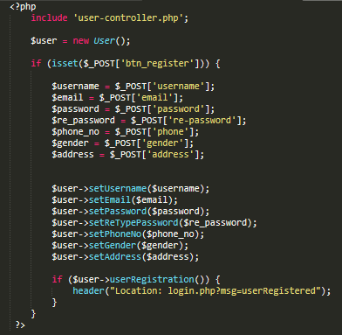

User Controller Code:

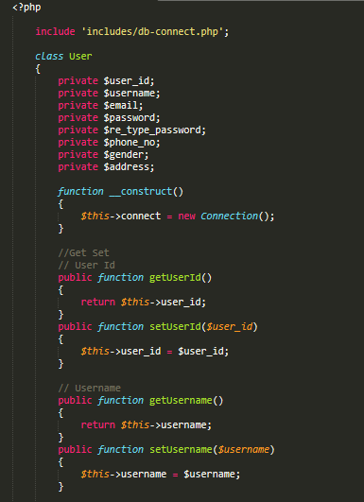

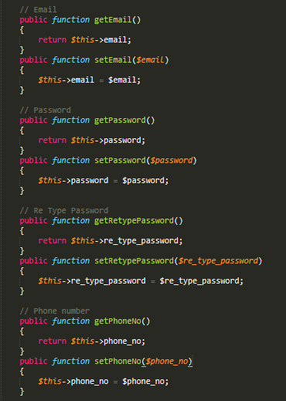

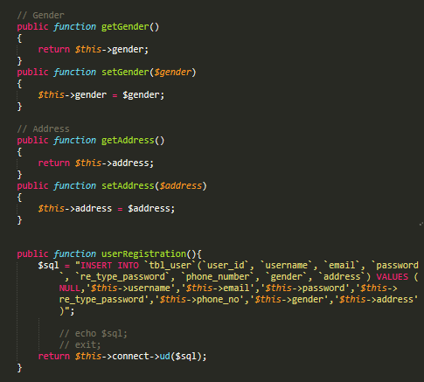

User Login Form:

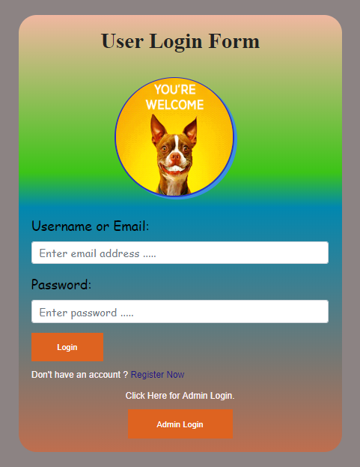

User Login Form Code:

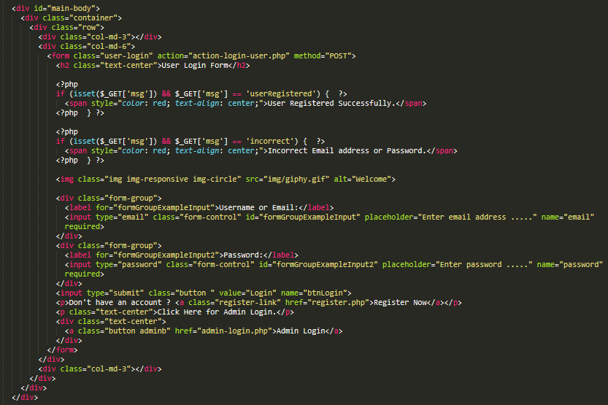

Login Action Code:

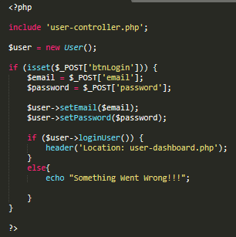

Login Controller Code:

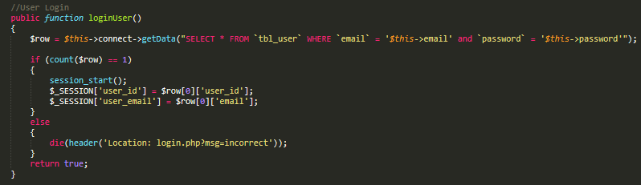

User Dashboard with their profile

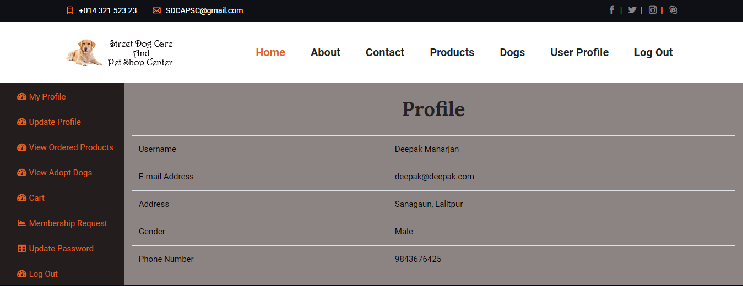

User dashboard Code with their profile

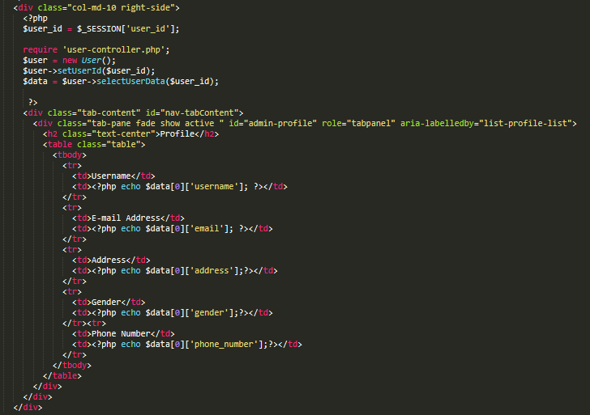

Fetch user profile data according to their profile from user controller:

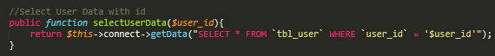

User Profile Update Form:

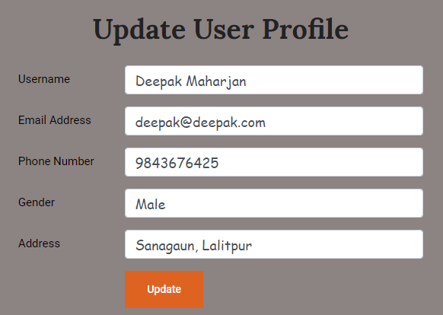

User Profile Update Form Code:

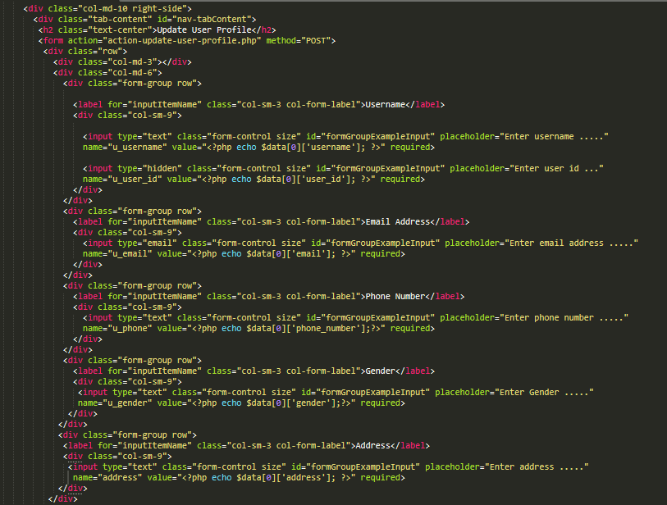

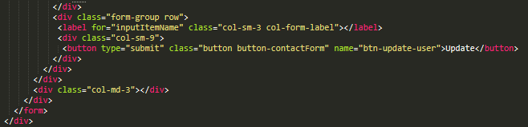

Update User profile action code:

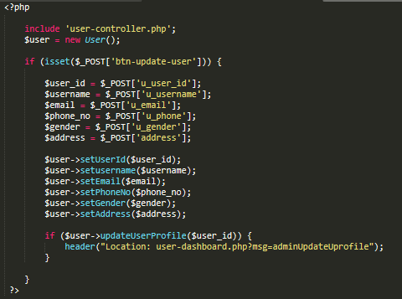

Update user profile controller code:

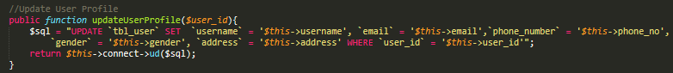

Membership request details:

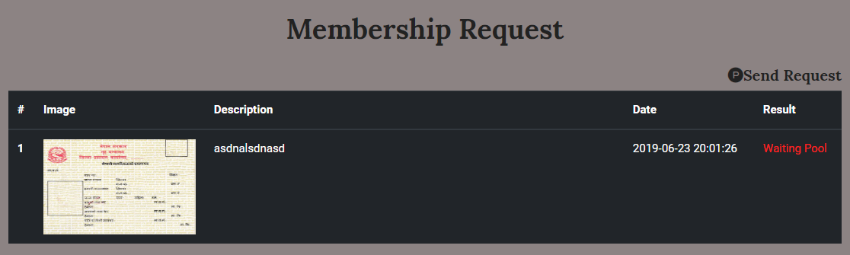

Send membership request form:

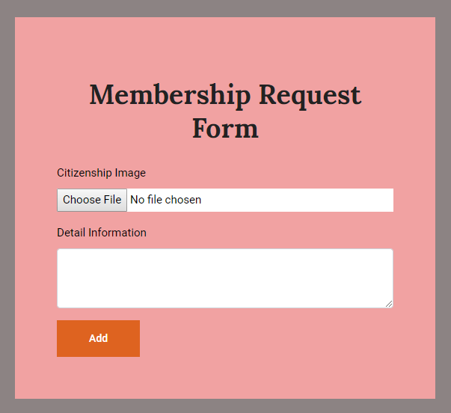

Membership request form Code:

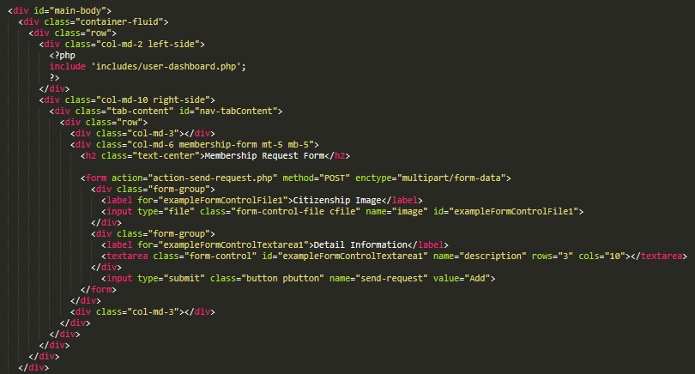

Membership controller to add on database:

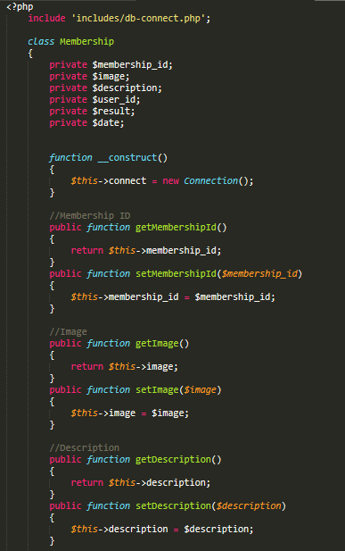

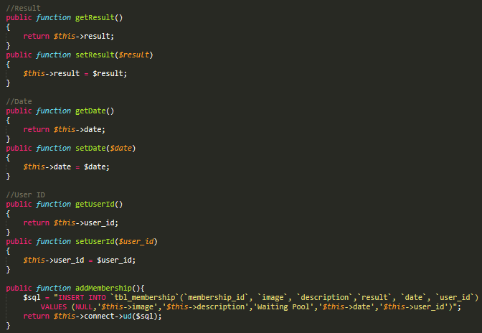

Fetch data from database of membership send by a specific user:

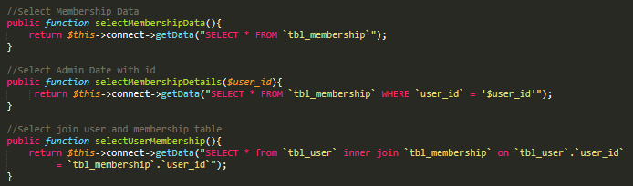

User change password:

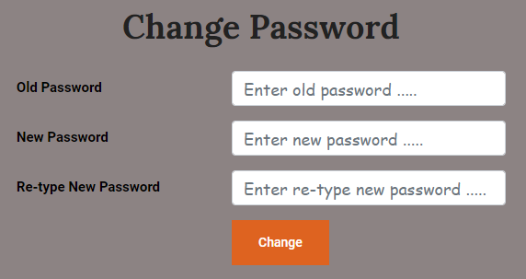

User change password form code:

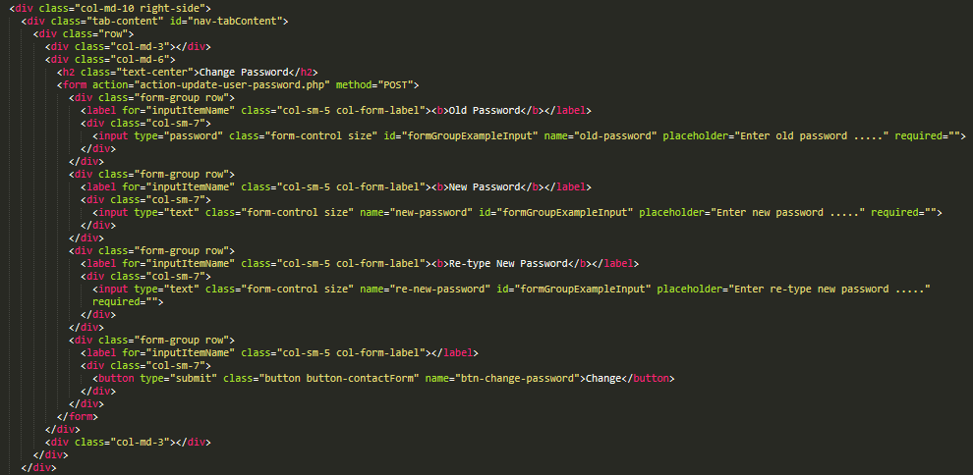

User update password action code:

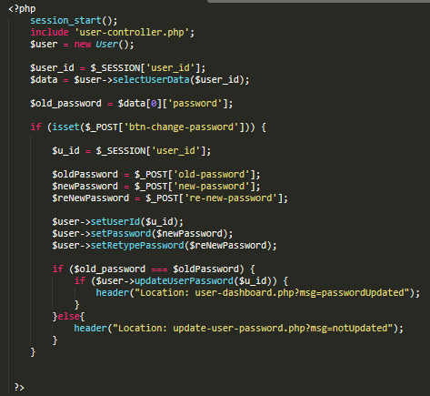

Change user password controller code:



User ask question form:

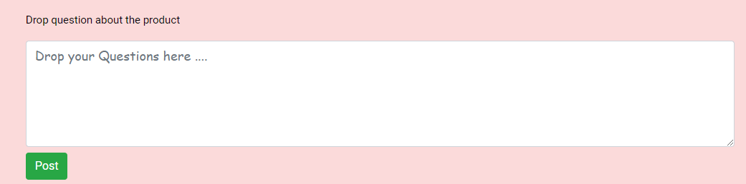

Ftech question data of specific question and display below the comment form: